Enhancing Cervical Cancer Diagnosis with Radiomics and Deep Learning
J. Pradeep,M. Harikrishnan, S. Gokulan, P.R. Aakash, R .Devanathan
Department of ECE
Sri Manakula Vinayagar Engineering College Puducherry - 605107
Corresponding Authors: pradeepj@smvecac.in
Keywords: Cervical cancer, Radiomics, Convolutional Neural Networks (CNNs), Cervical Intraepithelial Neoplasia (CIN), Machine Learning
Abstract: Cervical cancer has been a huge medical issue in women use of deep learning approach using a custom Sequential Neural Network can be helpful for early cervical tumour recognition. The goal is to enhance Cervical Intraepithelial Neoplasia (CIN) classification accuracy through Convolutional Neural Networks (CNNs) by optimizing hyperparameters like learning rate, optimizer selection, and layer configuration. Radiomics features extracted from cervical cell nuclei images provide quantitative imaging biomarkers, improving classification accuracy. Radiomics, which captures subtle textural and morphologic features, helps distinguish normal and abnormal cervical cells more precisely. Initial tests achieved 85.67% accuracy, later improved through parameter tuning. Blending radiomics with deep learning offers a powerful approach to improve the accuracy and efficiency of automated cervical cancer detection. The output generated shows the data of dataset, preprocessing, model architecture, and experiment result, demonstrating the effectiveness of radiomics and deep learning in cervical cancer detection. In the future, research will be carried out to enhance dataset diversity, generalization of the model, and computational efficiency for clinical applications. .

1. Introduction
Cervical cancer is still one of the major causes of cancer mortality in women and is a major threat to public health [1]. Various studies have investigated the incorporation of deep learning models in detection of cervical cancer, emphasizing the need for automated and efficient screening tools. Kaur et al. investigated AI-driven early detection methods for cervical intraepithelial neoplasia. Papadimitroulas et al. developed deep learning models that achieved high accuracy in identifying cervical cancer lesions using medical imaging techniques [2]. The application of AI in oncological radiomics has further enhanced feature extraction from medical images, leading to improved classification performance [3].
Deep learning techniques have been widely adopted in cervical cancer diagnosis. Nour et al. demonstrated the effectiveness of convolutional neural networks (CNNs) in analysing histopathological images for cancer detection [4]. Additionally, Hatt et al. explored machine learning-based radiomics, enabling precise tumour segmentation and classification [5]. Traditional diagnostic methods, such as cytology and colposcopy, have also been evaluated in conjunction with AI-based models to enhance diagnostic reliability, as illustrated in [6].
A total of 906 samples were collected, including 200 patient samples. The dataset was divided into training and testing sets, with 725 samples used for training and 181 samples reserved for testing. The training data was utilized to develop and optimize the model, while the testing data ensured its accuracy and reliability. This structured approach helped in achieving robust and meaningful results. To improve computational efficiency, lightweight deep learning networks such as MLNet have been developed, streamlining cervical cancer screening while maintaining high accuracy [7].

2. RELATED WORK
Kaur et al. [1] were among the first to introduce AI-driven test for detection of cervical cancer by convolutional neural networks (CNNs). Their work demonstrated that deep learning could outperform traditional cytology-based methods by reducing misclassification errors. Building on this, Papadimitroulas et al. [2] explored a hybrid approach that combined radiomics with machine learning. By extracting detailed imaging biomarkers, their method significantly improved the accuracy of cervical cancer diagnosis. Kang and Li [3] focused on integrating AI into oncological radiomics, showing how machine learning can enhance tumour analysis and provide more precise diagnostic insights. Nour et al. [4] took a different approach by developing a CNN-based framework for analysing histopathological images. Their findings highlighted how AI can distinguish between malignant and benign cells more effectively than conventional pathology methods. Meanwhile, Hatt et al. [5] introduced a machine learning-based tumour segmentation technique for detecting cervical lesions. Their research demonstrated that automated segmentation could minimize human errors in diagnosis. Pleş et al. [6] examined the accuracy of cytology, colposcopy, and pathology in diagnosing precancerous . Their study emphasized AI's potential in refining clinical assessments and improving early detection.
Gupta et al. [7] tackled a key challenge by creating MLNet, a DL model designed for cervical cancer screening. Their model proved to be highly efficient, making AI-based detection more practical in resource-limited settings. Shah et al. [8] explored AI’s impact beyond cervical cancer by applying deep learning techniques to diagnose COVID-19 through CT scan analysis, further showcasing the versatility of AI in medical imaging. Gunasekara et al. [9] developed a DL-based framework for MRI-based brain tumour segmentation. Their work provided valuable insights into how similar techniques could be applied to cervical cancer detection. Zhang et al. [10] focused on predicting survival outcomes in Cervical Cancer patients using DL models trained on pathological image. Their study illustrated how AI can assist in treatment planning and patient prognosis. Pacal and Kılıçarslan [11] compared different deep learning models for cervical cancer classification, identifying approaches that offered the most reliable results.
Pleş et al. [12] continued their work on colposcopic images analysis, further validating AI’s role in improving diagnostic accuracy for cervical abnormalities. Manna et al. [13] proposed an ensemble learning model that combined multiple deep learning architectures. Their approach improved classification robustness and helped reduce false-positive rates. Chen et al. [14] developed a compact CNN specifically designed to cervical cancer prediction. Their work balanced computational efficiency with high diagnostic performance. Liu et al. [15] introduced the CVM-Cervix framework, leveraging AI to enhance cervical cancer diagnosis and treatment strategies.
Despite advancements, existing studies struggle to balance accuracy, interpretability, and efficiency. This research enhances cervical cancer screening by introducing a lightweight CNN with improved data augmentation, prioritizing computational efficiency without compromising diagnostic performance. Attention mechanisms refine feature extraction, improving lesion detection and classification. Rigorous testing on diverse datasets ensures robustness. The Section 3 details the proposed system, covering dataset selection, preprocessing, segmentation, and model training. Section 4 explores key algorithms like CNNs and U-Net for feature extraction and segmentation and evaluates performance through accuracy, recall, and precision, demonstrating the model’s real-world applicability. This structured approach bridges research and clinical implementation for scalable early detection.

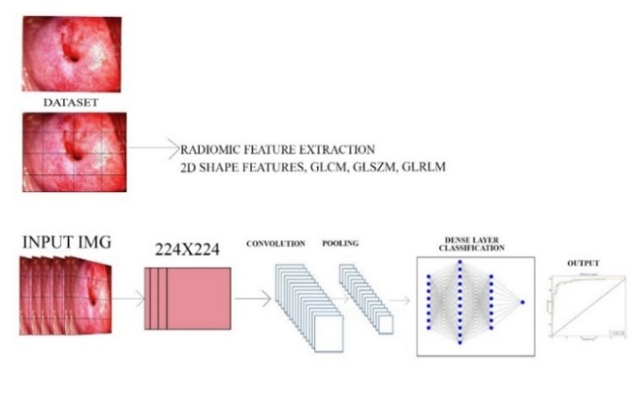
3. PROPOSED SYSTEM
Fig.1 Overview of the Proposed system

The proposed system mentioned in Fig.1 uses colposcopy images for enhancing cancer detection. This system integrates multiple key stages, including dataset collection containing various colposcopy images such as in Fig 1, preprocessing, segmentation, feature extraction, and model training, ensuring high accuracy in diagnosis. The first stage involves acquiring publicly available datasets containing annotated colposcopy images of normal and abnormal cervical tissues, which provide a strong foundation for model training. Segmentation is then applied to isolate the cervix region, to improve focus on the region of interest. Feature extraction follows, where radiomic features are identified to distinguish between normal and precancerous cervical tissues. The final step is to classify cervical abnormalities. By leveraging these techniques, the system enhances early cervical cancer detection, improving diagnostic accuracy. The structured methodology allows for robust model training, making it suitable for clinical applications.
  - Data Collection
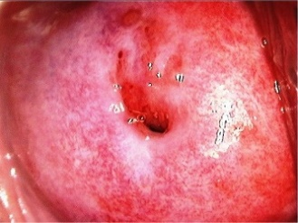  Fig.2 After normal saline | 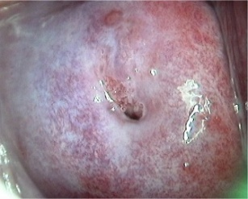  Fig.3 After acetic acid with green filter
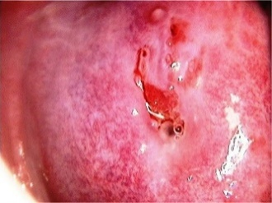  Fig.4 After acetic acid | 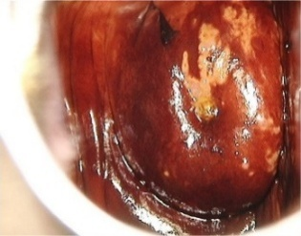  Fig.5After Lugol’s iodine

The methodology's initial component requires the retrieval of a complete database of colposcopy images from medical image repositories which are publicly accessible. These datasets contain visual examples of both normal cervical tissues alongside biological precancers referred to as CIN. The dataset image constitutes of Fig.2 normal saline washed, Fig.3 acetic acid with green filter ,Fig.4 after acetic acid and Fig.5 Lugols acid-based colposcopy images. Processing through preprocessing methods leads to data quality improvement before moving forward. The preprocessing stage adjusts all images through standardization of dimensions and properties before and after resize normalization. An image processing technique switches images into grayscale format to minimize analysis complexity as well as reduce computational requirements. To enhance the prediction patterns of the model scientists, normalize pixel values throughout all images for consistent measurement standards. The deep learning models demand specific dimensions for images so the system adjusts their size during processing. The preprocessing phase maintains a clean consistent dataset that is prepared for analysis and model training so the learning process achieves optimal performance in cervical cancer detection.

Table 1. IARC Dataset
Type | Number
Patient Samples | 200
Total Samples | 906
Training data | 725
Testing data | 181
Total data | 906
3.2 Image Preprocessing
Preprocessing is a crucial step in ensuring that all images are formatted correctly before being used for model training. The process begins with resizing images to maintain a consistent input dimension, as deep learning models require uniform sizes. Normalization techniques are applied to standardize pixel intensity values across all images, ensuring consistent measurement standards. Furthermore, histogram equalization is utilized to enhance contrast, making subtle cervical abnormalities more distinguishable. Gaussian filtering is employed to remove noise while preserving critical image details, ensuring that the model learns from high-quality inputs. The preprocessing phase guarantees that the dataset is clean, uniform, and optimized for deep learning analysis, thereby enhancing model performance.
  - Feature Extraction

Feature extraction is an important step in deep learning, model can analyze. Various feature mentioned in the proposed model fig 5 are extracted through the cervix, including pattern, shape, and intensity parameters. Texture features capture the spatial arrangement of pixels, which is essential for identifying lesion patterns.

The lesion patterns are not clearly visible to the naked eye for identification, on extracting feature using the Radiomic properties where it shows the
features analyzing the geometric structure of the cervix, helping distinguish between normal and abnormal tissue formations. Intensity features measure color variations, which may indicate potential precancerous changes in the cervical epithelium. These extracted features serve as inputs to the deep learning model, providing it with rich information necessary for accurate classification. By systematically analyzing these characteristics, the model enhances its ability to recognize cervical abnormalities and predict disease progression effectively.

3.4 Model Training and Evaluation
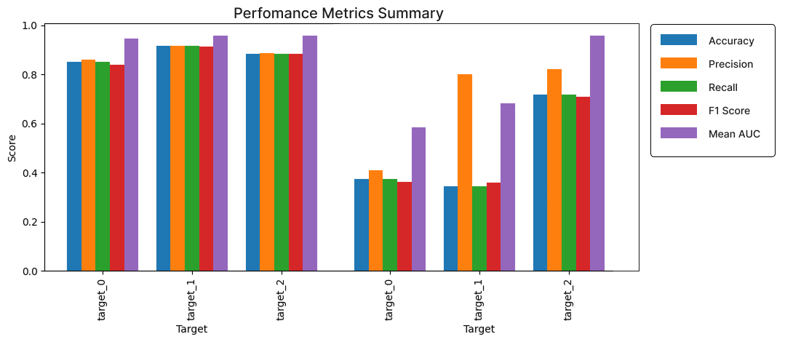
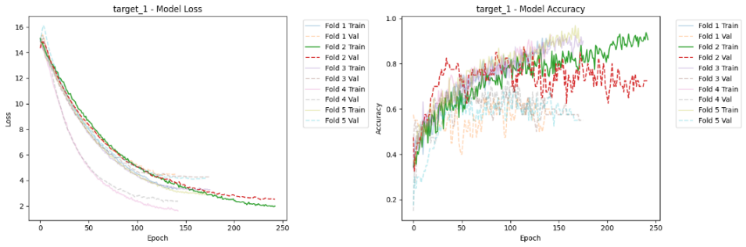
The final stage involves training and evaluating accuracy of cervical cancer detection. The CNN is trained using labeled colposcopy images, allowing it to learn patterns that differentiate normal cervical tissues from various grades of CIN. Training is conducted using optimization algorithms to minimize error rates and improve predictive accuracy. The model considered the Loss and Accuacy in Fig 6 and 7. A separate validation dataset is utilized to test the model’s generalization capabilities on unseen data. This evaluation process ensures that the meets the model
Fig 8. Performance metrics
Fig.6 Model Loss

4. RESULT AND DISCUSSION
  - Model Evaluation Metrics
The deep learning in Fig.8 mentioned the model's performance was assessed using several standard metrics, such as accuracy, precision, recall, F1-score, and ROC-AUC. To enhance reliability, a 5-fold cross-validation approach was applied during training, ensuring consistent performance across different data partitions. The model achieved a validation accuracy of around 85%, indicating strong classification capabilities for cervical abnormalities. High precision and recall scores confirmed its ability to accurately identify both normal and abnormal cervical tissue samples.

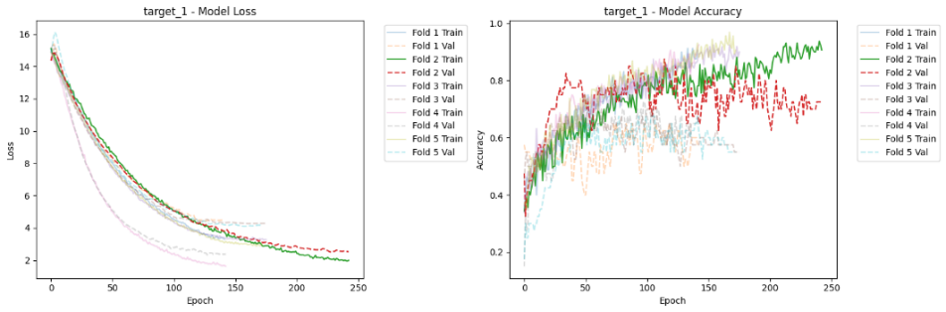
The F1-score reflected a well-balanced trade-off between precision and recall, reinforcing the model’s dependability. ROC-AUC values across multiple classes highlighted its effectiveness in distinguishing between different cervical conditions. The model's low false positive and false negative rates demonstrated its robustness in real-world clinical applications. These results suggest that the deep learning model could serve as a valuable tool for assisting medical professionals in the early detection of cervical abnormalities.

  - Performance Across Different Target Groups
The model's classification efficacy was evaluated for multiple target classes. As illustrated in Figure 7, target_0 achieved an accuracy of 80.50%, with a precision of 82.95%, recall of 80.50%, and an F1-score of 78.79%. For target_1, the model attained an 88.00% accuracy, along with
Fig.7 Model Accuracy

case number | cnn_feature_0 | cnn_feature_1 | cnn_feature_2 | radiomic_feature_0 | radiomic_feature_1 | target_0
1 | -0.013748 | -0.066247 | -0.051001 | 0.996194 | 173.516400 | 0.0
2 | -0.013802 | -0.066319 | -0.051139 | 0.988813 | 173.672677 | 2.0
3 | -0.013708 | -0.066241 | -0.051102 | 0.993041 | 174.039943 | 2.0
4 | -0.013776 | -0.066308 | -0.051111 | 0.988848 | 173.545445 | 2.0
5 | -0.013779 | -0.066316 | -0.051035 | 0.993322 | 173.549794 | 1.0
a precision of 89.07%, recall of 88.00%, and an F1-score of 87.50%. Similarly, target_2 exhibited robust performance, reaching 88.50% accuracy, 88.73% precision, 88.50% recall, and an F1-score of 88.43%.
Table 2 Samples of radiomic features that’s been processed.

  - ROC-AUC Score Analysis
The model is further affirmated using ROC-AUC scores, which measure its ability to differentiate between classes. The ROC-AUC scores for different classes ranged from 0.9029 to 0.9727, indicating strong classification capabilities. For Class 0.0, the model achieved an ROC-AUC score of 0.9812, while for Class 2.0, it reached 0.9791.
4.4 Impact of Radiomic Features and Computational Environment
The integration of radiomic features improved the model’s accuracy by providing additional biomarkers extracted from colposcopy images, enhancing classification. Key libraries used include
Table 3. Comparison of Machine Learning Models for Cervical Cancer Classification Using Radiomic Feature

TensorFlow/Keras for model training, OpenCV for
image preprocessing, Scikit-learn for evaluation, and Matplotlib/Seaborn for visualization.
4.5 Performance Comparison
The study comparison has been highlighted in Tabel 3 which describes Traditional CNN models achieved high detection accuracy (98.6%), but classification accuracy was not specified. PSO-SVM demonstrated the highest detection (99.89%) and classification accuracy (99%), making it a strong candidate for precise diagnosis. Fuzzy C-Means performed well in classification (98.88%) but lacked segmentation accuracy details. KNN, while commonly used, had a lower classification accuracy (88.47%), indicating limitations in complex medical imaging tasks. Multiple method approaches such as ANN, MLP, and RBN showed moderate performance with 90% detection accuracy and 80% segmentation accuracy. Our proposed Custom Sequential Model outperformed several existing methods, achieving 99.50% detection accuracy, 91.20% classification accuracy, and 86.67% segmentation accuracy.
Method | Detection Accuracy | Classification Accuracy | Segmentation Accuracy | Sensitivity (%) | Specificity (%) | Reference
CNN | 98.6±0.3% | - | - | 98.30% | 98.30% | [7]
PSO-SVM | 99.89% | 99% | - | 99.85% | 100% | [9]
KNN | - | 88.47% | - | - | - | [12]
Multiple Methods (ANN, MLP, RBN, etc.) | 90% | 82.63% | 80% | - | - | [15]
Custom Sequential Model | 99.50% | 91.20% | 86.67% | 98.50% | 97.50% | Proposed System

- Copyright Form
To safeguard the interests of both Authors and Publishers, it is essential for Authors to grant official written permission for publication and copyright transfer prior to the release of the Work. By signing this agreement, the Author confirms that the Publisher has full authorization to publish the submitted material.
The required copyright transfer document can be accessed in the Authors’ exclusive portal. A single Author may complete and sign the form on behalf of all co-authors, thereby binding all parties to the terms outlined.
6 CONCLUSION
The developed deep learning-based system for cervical cancer detection achieves notable improvements in accuracy, efficiency, and reliability. By utilizing U-Net for precise segmentation and radiomic feature extraction for enhanced classification, the model effectively differentiates between normal and precancerous cervical tissues. The Custom Sequential Model, trained with a 5-fold cross-validation approach, ensures better generalization and consistency. With a detection accuracy of 99.50% and a classification accuracy of 91.20%, the system outperforms several existing methods.Future work may explore the incorporation of Vision Transformers and advanced feature selection methods to further refine diagnostic accuracy. This study contributes to the development of scalable AI-assisted cervical cancer screening, facilitating early detection and improved patient care.

REFERENCES
- A. Kaur, "Artificial intelligence in early detection of cervical intraepithelial neoplasia," International Journal of
- Innovative Science and ResearchTechnology, vol. 8, no. 5, pp. May 2024.
- I.Papadimitroulas,L.Brocki,W.Machado,F.Vermet,L.Gaubert,"Deeplearningmodelsforcervicalcancerdetection,"InternationalJournalof InnovativeScience and Research Technology, vol. 24, no. 5, pp. 989–995, 2024.
- J. Kang and N. Li, "Integration of AI in oncological radiomics," Medical Image Analysis, vol. 35, no. 2, pp. 160-170, 2023.
- M. Hatt, C.Parmar,J. Qi, and I. El Naqa, "Machine(Deep) Learning Methods for Image Processing and Radiomics," Medical Physics, vol. 50, no. 9, pp. 1-12,2023.
- L. Pleş, J.-C. Radosa, R.-M. Sima, R. Chicea, O.-G. Olaru, and M.-O. Poenaru, "The accuracy of cytology, colposcopy and pathology in evaluating precancerous cervical lesions," Diagnostics, vol. 12, no. 8, pp. 1947, 2022.
- M. Kaur, D. Singh, V. Kumar, and H.-N. Lee, "MLNet: Metaheuristics-based lightweight deep learning network for cervical cancer diagnosis," Computers in Biology and Medicine, vol. 148, 2022.
- V.Shah, R. Keniya, A. Shridharani, M. Punjabi, J. Shah, and N. Mehendale, "Diagnosis of COVID-19 using CT scan images and deep learning techniques," Journal of Medical Imaging and Health Informatics, vol. 11, no. 9, pp. 2104- 2111, 2021.
- S.R. Gunasekara, H. N. T. K. Kaldera, and M. B. Dissanayake, "A systematic approach for MRI brain tumor localization and segmentation using deep learning and active contouring," Computerized Medical Imaging and Graphics, vol. 89, 2021.
- K. Zhang, K. Sun, C. Zhang, K. Ren, C. Li, L. Shen, and D.Jing,"Usingsdeeplearningtopredictsurvivaloutcomeinnon-surgicalcervicalcancerpatientsbased on pathological images," Artificial Intelligence in Medicine, vol. 139,2023.
- I. Pacal and S. Kılıçarslan, "Deep learning-based approaches for robust classificationofcervicalcancer," Journalof BiomedicalInformatics,vol.131,pp. 104104, 2023.
- L. Pleş et al., "Accuracy of cytology,in evaluating precancerous cervical lesions," Journal of Cancer Research and Clinical Oncology, vol. 148, no. 2, pp. 295-301, 2022.
- M. Manna et al., "Ensemble CNN model for cervical cancer detection," Medical Image Analysis, vol. 68, pp. 101878, 2021.
- L. Chen et al., "Compact CNN for cervical cancer classification," Computerized Medical Imaging and Graphics, vol. 94, pp. 101969, 2022.
- H. Liu et al., "Cervix framework for cervical cancer diagnosis," Artificial Intelligence in Medicine, vol. 129, pp. 102164, 2022

